Yifeng Liao & Talal Al-Otaibi
ME 348F: Advanced Mechatronics 2
Professor Zhou
October 17, 2022

Lab 3 Report

Parameters for the Tuned Controller:
- Kp = 0.514
- Alpha = 10
- Tau = 0.00084
- Ti = 0.03
- Low-pass cutoff frequency: 1000 hz

Frequency responses for the plant (P(s) = X(s)/VR(s)), the loop return ratio (L = C(s) · P(s)), and the closed-loop system:

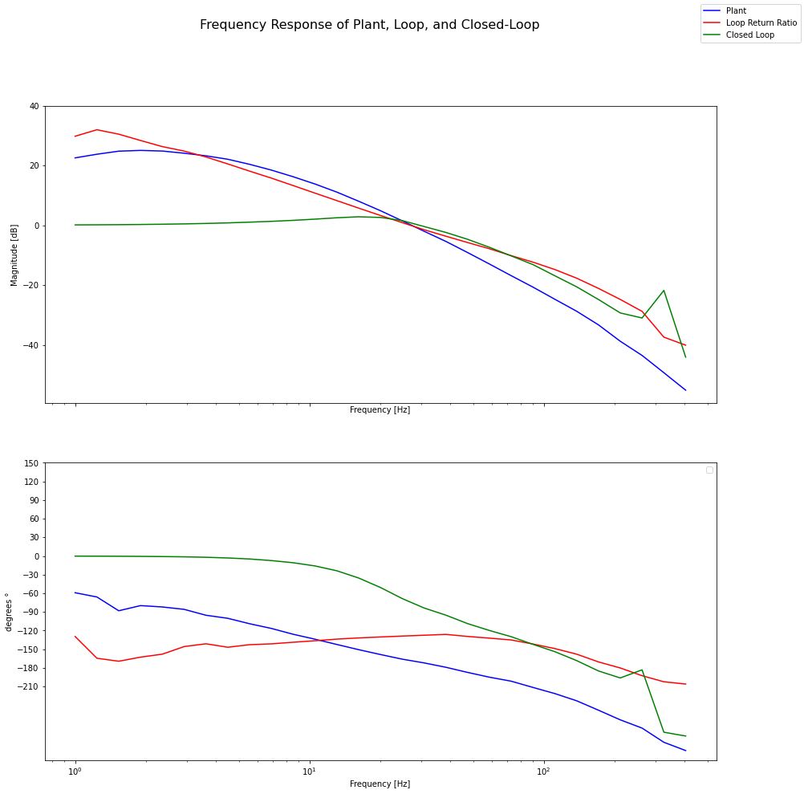
The experimental crossover frequency of the Loop return ratio is 27 hz, and the bandwidth of the Closed-Loop is 32 hz. They are almost the same and both satisfy the requirement of at least 25 hz. In addition, the phase margin of the Loop return ratio is about 44 degrees, which is higher than the requirement of 40 degrees. Note that tuning efforts also ensured that the controller slope was -1 (-20dB/dec) over frequencies less than 5Hz and also -1 over frequencies greater than 1 KHz. It appears that the slope of the closed loop transfer function is negative above the low-pass break frequency of 1KHz.

Predicted Step Response for the Tuned Controller:
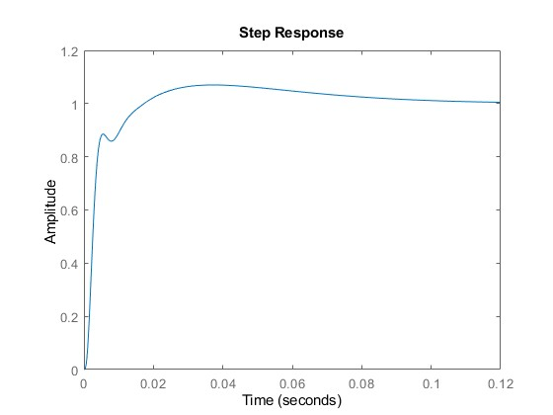
Note that the change in concavity (small peak) appears because of the effect of the Integral gain. By implementing the Ti term, the step response amplitude value increases to mitigate the effect of steady state error. This explains the rise of the value from the first small peak of 0.9 gradually over time to be as close to 1 as possible, thus reducing steady state error.
Experimental Step Response for Tuned Controller:
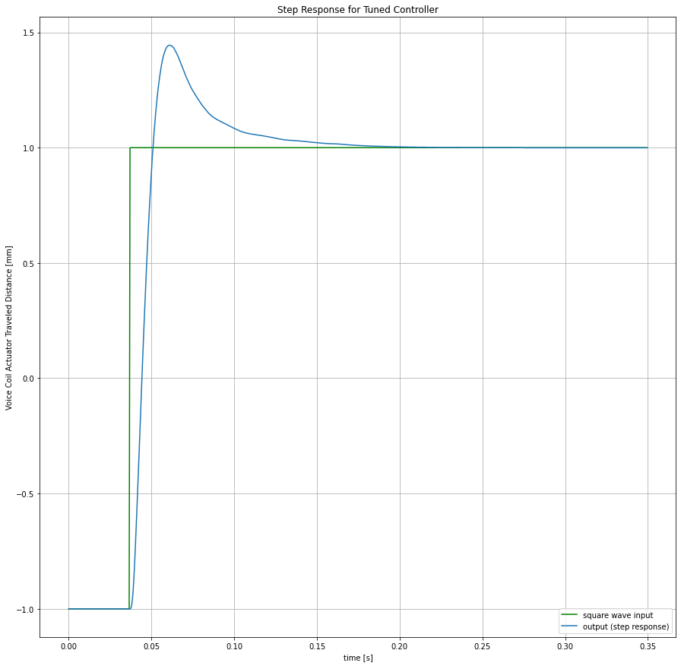

The experimentally obtained step response does not quite match the predicted step response, this is because the theoretical model dynamics does not completely encapsulate the true system dynamics. Compared to the theoretical step response, there is only one overshoot at around 1.45mm before a gradual decay and convergence to the steady state value of 1mm.

Trapezoid Trajectory Tracking Performance using v_max = 300 mm/s and a_max = 100 mm/s^2:
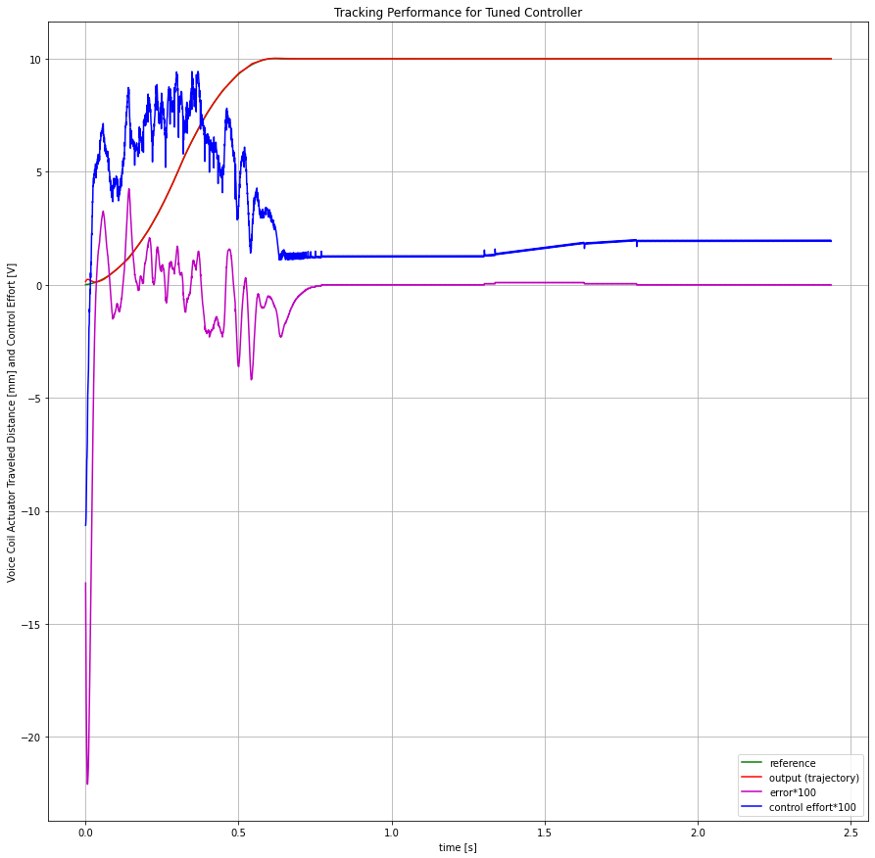

The graph above shows the tracking performance of the tuned controller to a trapezoidal trajectory with 300 mm/s maximum velocity and 100 mm/s^2 maximum acceleration. The error and the control effort are multiplied by 100 for visualization purposes. We see that the control effort is largest while the actuator is moving according to the trajectory, and the error is largest when the trajectory reaches 10 mm due to overshoot. Overall, when the system is in motion, the tracking error does appear to be prominent. Further care in selecting the maximum velocity and maximum acceleration can help minimize the tracking error.

Note: error is defined by reference value - output trajectory in mm.

